Round Table Discussion: Opening Our Doors

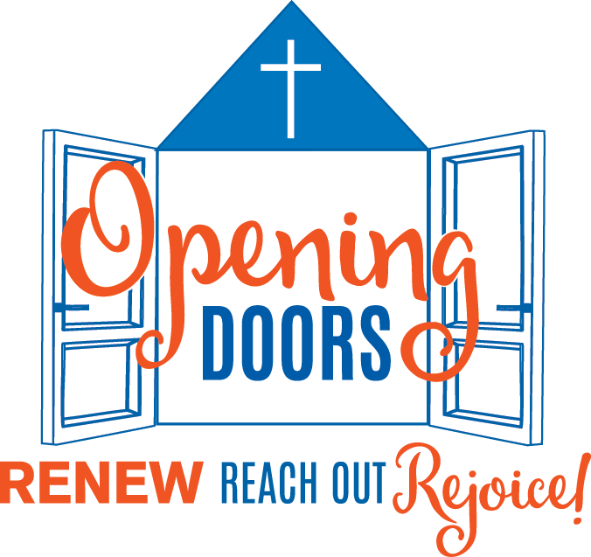
Looking back at 2016 we are incredibly thankful for the way our church has caught the vision of the Opening Doors campaign. To date we have raised $1,100,000 towards our Access Project! This is truly something to celebrate. In 2017 we look forward to the completion of the new accessible entrance to our church building. Yet as we move forward we must remember that the renovations to the building aren’t the end of our vision. The building project is a means to help us open our doors as a church to our local community and to the God who calls us to be his people.

Opening Our Doors to Jesus

In our sanctuary is a window that has Saint Andrew on one side and Jesus knocking on an overgrown door on the other. The image of Jesus is taken from the opening of the book of Revelation, where Jesus speaks to John of Patmos through a vision and sends a message to seven churches in Asia.

“Listen! I am standing at the door, knocking; if you hear my voice and open the door, I will come in to you and eat with you, and you with me… Let anyone who has an ear listen to what the Spirit is saying to the churches.” (Revelation 3:20–22)

The most important thing we have to offer the world is Jesus. By his grace, Jesus is always his church, but there are things we do to either welcome him in to the centre of our church or keep him out by the door. Faith opens the door to Jesus. By trusting that the Lord would enable us to carry out our Access Project, this congregation has already taken a step towards welcoming Jesus more fully into our midst. Now we need to consider our next steps.

Question 1: What sort of practices (e.g. prayer, study, fellowship, outreach) can we take up that will help us welcome Jesus even more fully into the centre of our church?

Opening Our Doors to Our Community

The primary reason for our building project is to make our church building more physically accessible and to present a more welcoming face to the community. Yet, becoming more accessible and welcoming is about more than just bricks and mortar. We need to think about who we want to welcome and how we can enable them to feel welcome. In particular, we need to look at our church from the perspective of someone coming to us for the first time.

Question 2: Who are the people in our community we need to make especially welcome in our church (ie. young people, families, seniors, unchurched people, professionals, those in need)? While we are called to welcome all people, who are those that we need to be intentional about welcoming into our church family?

Question 3: What do we need to do to make these people feel welcome? What are we doing well now? What do we need to do better or differently?

Here are some specific areas of our church life we can think about. If you have insights about other ways we are already making people feel welcome, or ways could become more welcoming, please share these as well.

3a) How welcoming is our worship service to new people (especially those who have been away from church for a long time, or have never been part of a church)? What are we doing well? What could we do better or differently?

3b) How welcoming is our building to new people? Apart from the planned renovations that are a part of the Accessibility project are the ways we could make our building more welcoming to newcomers?

3c) How well do greet and welcome people when they first come to our church (for worship or other church events)? How are we at following up with people after their first visit? How easy it is for new people to move from being a casual attender to a fully active member or adherent of St. Andrew’s?

Going Out Through Our Doors to Our Community

We open doors to welcome other people in, but we also open doors to go out into the world outside. Today in Canada we cannot assume that people will come to us, we need to go out to them. Indeed, we need to remember that Jesus says: “Peace be with you. As the Father has sent me, so I send you.” (John 20:21) Jesus also says: “Truly I tell you, whatever you did for one of the least of these brothers and sisters of mine, you did for me.” (Matthew 25:40) We are also called to serve people in need in our community who may never become a part of our church.

Question 4: What individuals or groups in our community should we intentionally reach out to? What individuals or groups in need might we be called to serve in mission?

